# TAJENDER VERMA

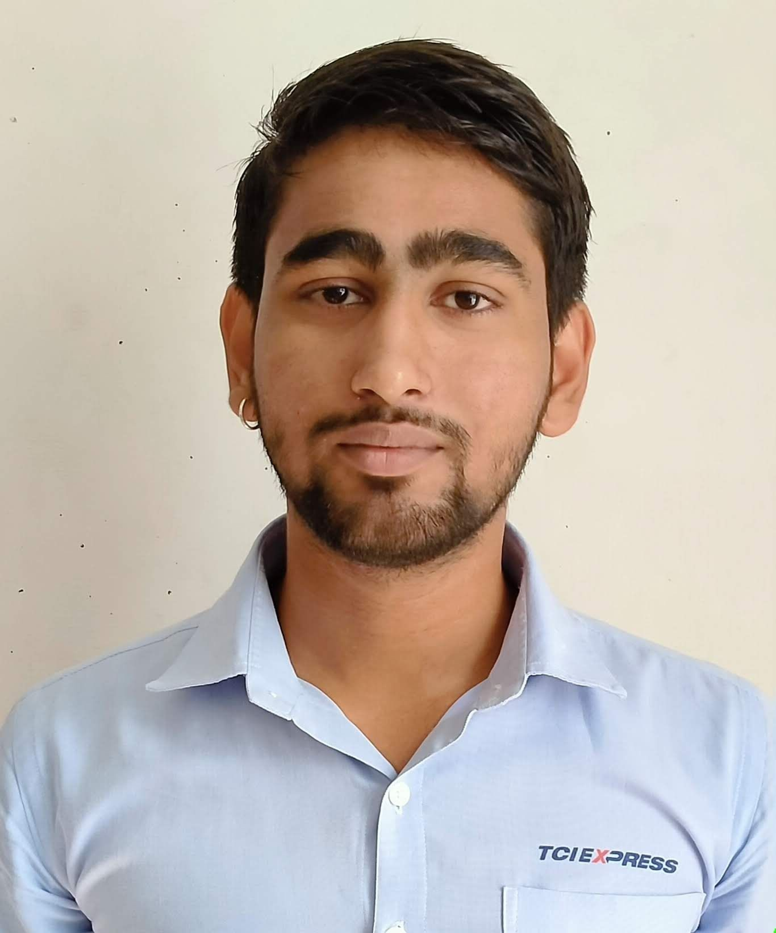

# Mobile: +919784142791

**Email:** [**Tejender978@gmail.com**](mailto:Tejender978@gmail.com)

### Professional Objectives

Aim to be an associate with a progressive organization that gives me scope to update my skills and knowledge in accordance with the latest trends and be part of a team that dynamically works towards growth of organization and gains satisfaction thereof.

**Organization Experience Current**

**Organization: TCI EXPRESS LTD**

**Designation: Account & Operation Supervisor**

**Duration: Aug-2018 to till date (5 Year Experience)**

**JOB PROFILE**

**Experience Summary**

* Presently working with TCI EXPRESS LTD from October 2018 & Now I am working as an Accounts Supervisor till date.
* Handling Customer Enquire, Solving Their Problems.
* Preparing Business Score Card Monthly
* Preparing Monthly Business Report
* Marketing Skills in Booking.
* Update Daily Business Performance
* Building teams and cultivating team work
* Looking Branch Functions Like Cash Handling, Branch Billing & Other EDP Related Works.

### Accounts Related Activities

* Maintaining party ledger
* Maintaining and reconcile the bank account
* Handling party cash, preparing cash & cheque vouchers.
* Maintaining outstanding statements & follow-up for Payments.
* Depositing the cheque & Cash updating daily collection.

### Academic Qualification:

* + 10th from RBSC Board, Ajmer in 2014.
  + 12th from RBSC Board, Ajmer in 2017.
  + B.com from OPJS University, Churu in 2017 to 2019.

### Technical Skill



* + Windows 7,10, Linux Mint, Linux Lite.
  + Ms-office(Word, Excel ,Power Point)
  + Accounting Package (Tally 9.0 GST)
  + RS-CIT (Rajasthan State Certificate of Information Technology)

### Skill Summary

* Excellent interpersonal and communication skills.
* Team building and motivation
* Relationship Management & Training Skills.

### Hobbies

* Listing Music
* Learning
* Web Browsing

**Personal Details**

## Father Name : Mr. Mangeram

## Mother Name : Mrs. Manju

Date of Birth : 15/09/1999

Present Address : Rajgarh, Churu (RJ)

Marital Status : Unmarried

Languages Known : Hindi and English

**DECLARATION**

I hereby declare that the information give about me is true to the best of my knowledge and belief.

**Date: …………...**

**Place: ……….…**

### (TAJENDER VERMA)